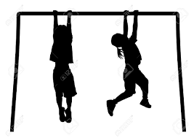
Ready to write? Use your muscles!

Children develop in a holistic manner and their physical development should be seen as being important as their intellectual development. Therefore, before young children learn to write they will benefit from experiences that support the development of gross and fine motor skills in the hands and fingers. Children should have strength and dexterity in their hands and fingers before being asked to manipulate a pencil on paper. Here are some fun activities children can do at home to develop these important skills.

Large Muscle Development – gross motor and locomotor skills
These activities develop body management, balance, co-ordination, strength, agility and conﬁdence. The joints a child’s body need to be stable before their hands can be free to focus on specific skilled fine motor tasks. Suggested activities include:
- Walk forwards, backwards and sideways
- Walk on tip-toes (balance)
- Running, stopping and starting
- Climb up steps or a ladder with one foot leading
- Jump up and down on the spot on both feet
- Jump a distance
- Sweeping the floor.
- Balance along a plank 18cms from the ground
- Balance on one leg for 4 seconds
- Crawl through a barrel or tunnel
- Crab walking, and wall push-ups
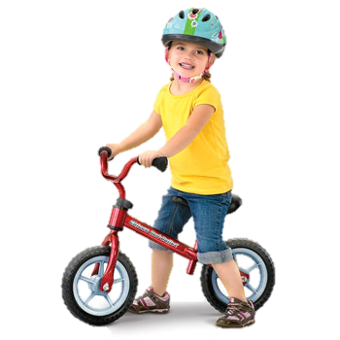
- Exploring playground equipment, for example, monkey bars, climbing apparatus, or ropes
- Dancing or marching to music, or moving to action rhymes.
- Catch a large ball between extended arms
- Kick a ball
- Pedal a bike or tricycle along a straight line
- Pull an empty truck around obstacles
- Throwing and catching balls and beanbags or throw them at a target (eg, a cardboard box or through an old tyre)

Sensory Activities
The following activities encourage large muscle strength and endurance. They also strengthen the child's awareness of his or her hands.
- Clapping games (loud/quiet, on knees, together, etc.)
- Catching (clapping) bubbles between hands
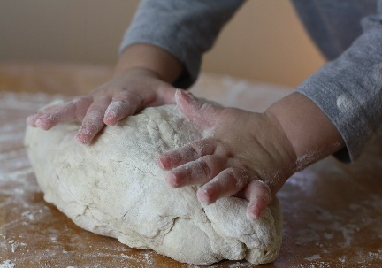
- Draw in a tactile medium such as wet sand, salt, rice, or "gloop.” Make "gloop" by adding water to cornflour until you have a mixture similar in consistency to toothpaste. This mixture, which although a liquid, offers resistance, provides feedback to the muscle and joint receptors, thus facilitating visual motor control.
- Mixing, rolling or kneading dough.
- Picking up small objects like pegs, beads, coins, etc., from a tray of salt, sand, rice, or putty. Try it with eyes closed too. This helps develop sensory awareness in the hands.

Midline Crossing
It takes time for children to establish hand dominance. Until they settle on a dominant hand, a child may switch hands at the midline when doing certain activities. The following activities help facilitate midline crossing:
- Encourage reaching across the body for materials with each hand. It may be necessary to engage the other hand in an activity to prevent switching hands at midline.
- Refrain from discouraging a child from using the left hand for any activity. Allow for the natural development of hand dominance by presenting activities at midline, and allowing the child to choose freely.
- Start making the child aware of the left and right sides of his body through spontaneous comments like, "kick the ball with your right leg." Play imitation posture games like "Simon Says" with across the body movements.
- When painting at an easel, encourage the child to paint a continuous line across the entire paper. Then also one from diagonal to diagonal.

Ocular Motor Control
This refers to the ability of the eyes to work together to follow and hold an object in the line of vision as needed.
- Use a flashlight against the ceiling. Have the child lie on his
or her back or tummy and visually follow the moving light from left
to right, top to bottom, and diagonally.
- Find hidden pictures in books or magazines.
- Practice maze activities.

Fine Motor Activities
These activities will help to build the strength and dexterity necessary to hold a pencil appropriately.
- Mould and roll Play-Doh into balls—using the palms of the hands facing each other and with fingers curled slightly towards the palm.
- Roll Play-Doh into tiny balls (pea size) using only the fingertips.
- Use pegs, toothpicks or small tools to make designs in Play-Doh
- Cut Play-Doh with a plastic knife.
- Tear newspaper into strips and then crumple into balls. Use the balls of paper as stuffing for scarecrows, puppets, or other art projects.
- Scrunch up one (1) sheet of newspaper in one hand—great for building strength!
- Pick up objects using large tweezers (eg as in the game ‘Operation’). This can be adapted by picking up Cheerios, small cubes, small marshmallows, pennies, etc., in counting games. Alternatively, challenge your child to pick up ball bearings, Hama beads or pom-poms with tweezers.
- Shake dice by cupping the hands together, forming an empty air space between the palms.
- Use small-sized screwdrivers to undo – or tighten – screws.
- Use sewing and threading/lacing activities, for example stringing beads, macaroni, or cut up drinking straws.
- Use eye droppers to "pick up" coloured water for colour mixing or to make artistic designs on paper.
- Roll small balls out of tissue paper, and then glue the balls onto construction paper to form pictures or designs.
- Turn over cards, coins, checkers, or buttons, without bringing them to the edge of the table.
- Make pictures using stickers or self-sticking paper (O) reinforcements.
- Play games with the "puppet fingers"—thumb, index, and middle fingers.
- Gummed shapes - Give the children a sheet of plain paper and ask them to make patterns or pictures with the gummed shapes. Just picking up on shape at a time, licking it and then sticking it down all help to develop hand/eye coordination and the pincer grip.
- Use pegs of different sizes, clothes pegs, small bulldog clips, stationery clips etc. Get the child to use one hand only at a time. Peg about 10 pegs of different sizes onto the sides of a gift bag. They might put them on with their left hand and take them off with their right. They can also try squeezing the pegs between the first finger and thumb (on each hand) then the middle finger and thumb and so on.
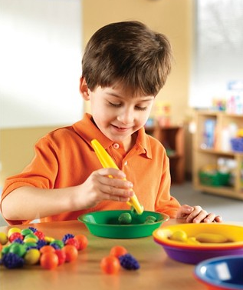
- Elastic gymnastics! - Start by putting 2 elastic bands (the same size) around the thumb, first and middle fingers, ask the child to open and close the fingers. Then add another 2 elastic bands and so on. The more you have on, the harder it is to move your fingers. These exercises help to develop the muscles which make the web space when writing.
- Children love stickers. Just peeling them off provides an opportunity to develop fine motor skills and hand/eye coordination.
- Washing plastic dishes.
- Locking and unlocking a door
- Winding a clock or wind-up toy.

Scissor Activities
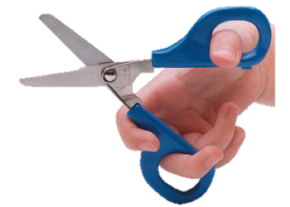
When scissors are held correctly and when they fit a child's hand well, cutting activities will exercise the very same muscles which are needed to hold a pencil correctly, that is, between the thumb and index finger with the pencil resting on the middle finger. The correct scissor position is with the thumb and middle finger in the handles of the scissors, the index finger on the outside of the handle to stabilize, with fingers four and five curled into the palm.
- Cut up junk mail or magazine subscription cards.
- Make fringe on the edge of a piece of construction paper.
- Cut Play-Doh into small pieces with scissors.
- Cut straws or shredded paper.
- Cut pictures out of catalogues or magazines.

Credits
therakids.org – Fine Motor Activities for Home
Early Years, The organisation for young children - Learning through physical play

