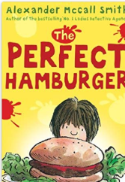
The Perfect Hamburger – Alexander McCall Smith (plus other stories by this author)
Roald Dahl stories
David Walliams Stories e.g. The Boy in the Dress
(a fun read!)
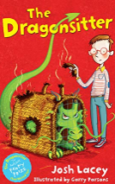
Tom Gates – Liz Pichon
Horrid Henry – Francesca Simon
Project X Alien Adventures
Steve Cole – Astrosaurs
Dirty Bertie – Alan McDonald
Beast Quest – Adam Blade
Frankie’s Magic Football – Frank Lampard
The Christmasaurus – Tom Fletcher
The Christmasaurus and The Winter Witch – Tom Fletcher
The Creakers – Tom Fletcher (Lots of children love this book but some find a little scary as there is a monster under the bed!!).
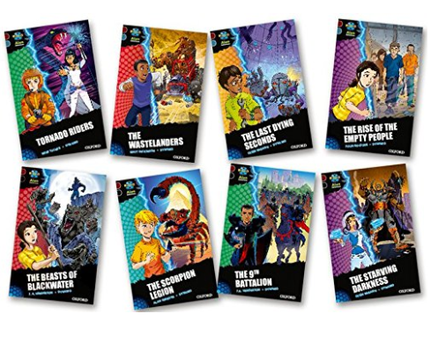
The Hodgeheg and Smasher - Dick King Smith
Greek Beasts and Heroes – Lucy Coats
Puppy Tales – Jenny Dale
Mr Birdsnest and the house next door – Julia Donaldson (other short chapter stories by Julia Donaldson too!)

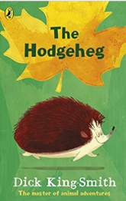
Little Legends – Tom Percival
The Dragon Sitter set – Josh Lacey
Magic Ballerina – Darcy Bussell
Flying Fergus – Chris Hoy

There are more on this website too;
https://www.booksfortopics.com/year-2

